**Making of IR Sensor Module**

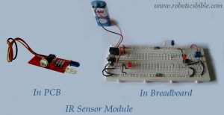

As per the reader’s request, here is the making of the IR Sensor Module. An IR Sensor module is a sensor that transmits and receives infra-red rays when a surface or object is detected. It is a multipurpose sensor, which can be used in [line following robot](http://www.roboticsbible.com/simple-line-following-robot.html), [obstacle avoiding robot](http://www.roboticsbible.com/project-obstacle-avoiding-robot.html), [edge avoiding robot](http://www.roboticsbible.com/project-edge-avoider-robot-without-microcontroller.html), etc.

**Components required:**

* Breadboard – 1 no
* IC LM358 – 1 no
* IC 7805 – 1 no
* IR Transmitter – 1 no
* IR Receiver – 1 no
* 10µf Capacitors – 2 nos
* 9V Battery – 1 no
* Battery Snap – 1 no
* 10K Trimpot – 1 no
* LED – 2 nos
* 10K Resistor – 2 nos
* 1K Resistor – 2 nos
* Breadboard Wires

**Circuit Diagram:**

[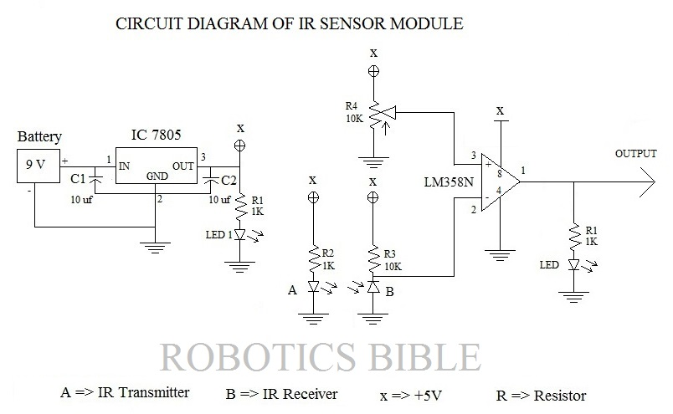](http://www.roboticsbible.com/wp-content/uploads/2013/07/Circuit-of-ir-sensor-module.jpg)

**Step by Step Instructions:**

**1)      5V Power Supply:**

* Take the breadboard and connect the battery holder in horizontal position.
* Insert the positive and negative wire of battery snap in holder.
* Attach IC 7805 (Voltage Regulator), and place one 10 µF capacitor in IN & GND connection of IC 7805 and other in GND & OUT connection.
* Take the positive supply from the battery holder via breadboard wire and place it in IN of IC 7805, and also connect its negative supply in the last row of the breadboard.
* Place the GND of IC 7805 in the last row of the breadboard, and transfer its OUT to the first row of the breadboard.
* As a result of these connections, +5V power is obtained in the first row of the breadboard.
* To check the power flow path, an LED is given a positive supply via 10K resistor.

**2)      IC LM358:**

* Take an IC LM358 and place it in the breadboard.
* Provide +5V to the 8th pin and GND to the 4th pin of LM358.
* Connect the LED’s +ve with the 1st pin of LM358 via 1K resistor and –ve to the GND.

**3)      IR Transmitter:**

* Place the IR transmitter in the breadboard and provide +5V to its cathode.
* A GND connection is given to its anode via the 10K resistor.

**4)      IR Receiver:**

* Place the IR receiver in the breadboard and provide +5V to its anode.
* A GND connection is given to its cathode via the 10K resistor.
* Connect the IR receiver’s cathode with the 3rd pin of LM358 using breadboard connection.

**5)      Trim pot:**

* Place a 10K trimpot in the breadboard, and provide +5V to its 1st pin and GND to its 3rd pin.
* Connect its 2nd pin with the 2nd pin of LM358.

**Working:**

Once the connection is finished, make sure the connections are given as per the circuit diagram. Now, show your hand towards the IR transmitter and receiver. In this case, an LED connected to the 1st pin of LM358 must glow as the IR transmitter emits IR rays and IR receiver receives the reflected ray.

The Op-Amp (IC LM358) compares the two inputs and provides the output which is higher.

If the LED fails to glow, then there is a problem in the circuit.

**Conclusion:**

Overall, I feel the making of IR Sensor Module would help my reader’s in developing the robots. This IR Sensor Module is recommended to be designed in PCB for better and reliable uses.

**Autonomous Quadrotor MeCam streams video to your Smartphone**

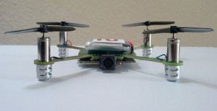

*Always Innovating*, a well known company for its Touch Book and Smart Book has come up with a new *flying video camera* called as MeCam. It is a *palm-sized* autonomous quadrotor that has *four spinning rotors* to keep them aloft. It is capable of following you by itself to *stream live video* to your smartphone. It also packs *several exciting features* with it, and let us have a short look at it:

**No Remote Control:**

MeCam can be controlled by *two ways* such as:

* *Voice Control* – It understands several voice commands like move up or down
* *Follow Me* – You can enable ‘follow me’ feature to follow you around while capturing mesmerizing video

**Hardware:**

* Always Innovating Module
* ARM Cortex A9 processor
* 1 GB RAM
* Wi-Fi
* Bluetooth

**Technology:**

MeCam incorporates *14 different sensors* to avoid obstacles in its path. It also has *stabilization technology* to capture non-shaky videos on the move. Moreover, it allows you to *share* the videos to Facebook, YouTube, etc.

**Availability and Price:**

The company has started *licensing* the design of MeCam products, and expected to release it in *early 2014* for a price of *$49*.

Bottom of Form

**Mobile Controlled Robot via GSM**

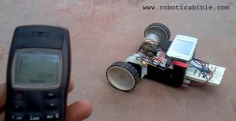

Controlling a robot wirelessly is possible with several methods such as Remote, Bluetooth, Wi-Fi, etc. But, the controls of these communication methods are limited to certain areas, and complicated to design as well. To overcome these difficulties, we have come up with a Mobile Controlled Robot.

A Mobile Controlled Robot is a mobile device, which provides wide-range of wireless control ability to your robot unless your cell phone gets out of signal.

A general concept of mobile controlled robot is that it can be controlled from any part of the world with just an inclusion of a camera. We will definitely offer you the simplest method for developing this kind of robot in the coming days.

Now, we like to introduce the simplest technique of fabricating a Mobile Controlled Robot via GSM. As we have [eliminated the use of a microcontroller](http://www.roboticsbible.com/category/projects-robotics), it could certainly help the beginners to feel better.

**Components Used:**

The components used in making this robot are easily available in electronic markets and very cost effective too. The following list provides the complete component requirements of this robot.

* Robot Chassis
* 12V DC Motor (60 RPM) – 2 nos.
* Breadboard – 1 no.
* [IC L293D](http://www.zartronic.fr/doc/Z1/L293D_ST.pdf) – 1 no.
* [IC CM8870](http://www.datasheetcatalog.org/datasheet/calmicro/CM8870.pdf) – 1 no.
* IC 7805 – 1 no.
* 9V Battery – 1 no. (Requires according to the usage)
* Plastic Wheels – 2 or 4 nos. (Based on the chassis)
* Castor Wheel – 1 no. (Requires only when two wheels are used)
* 10 µf Capacitors – 2 nos.
* 0.1 µf Capacitors – 2 nos.
* 3.58 MHz Oscillator – 1 no.
* 1K Resistor – 1 no.
* 100 K Resistor – 2 nos.
* 300 K Resistor – 1 no.
* Universal Headphone Jack – 1 no.
* LED – 1 no.
* Breadboard Wires – 2 meters
* Battery Holder – 1 no.
* Battery Snap – 1 no.

*Note: We recommend you to buy spare IC’s for all the IC specified in the component list. This could sometime help you to save your precious time if one IC fails to operate.*

**Circuit Diagram:**

[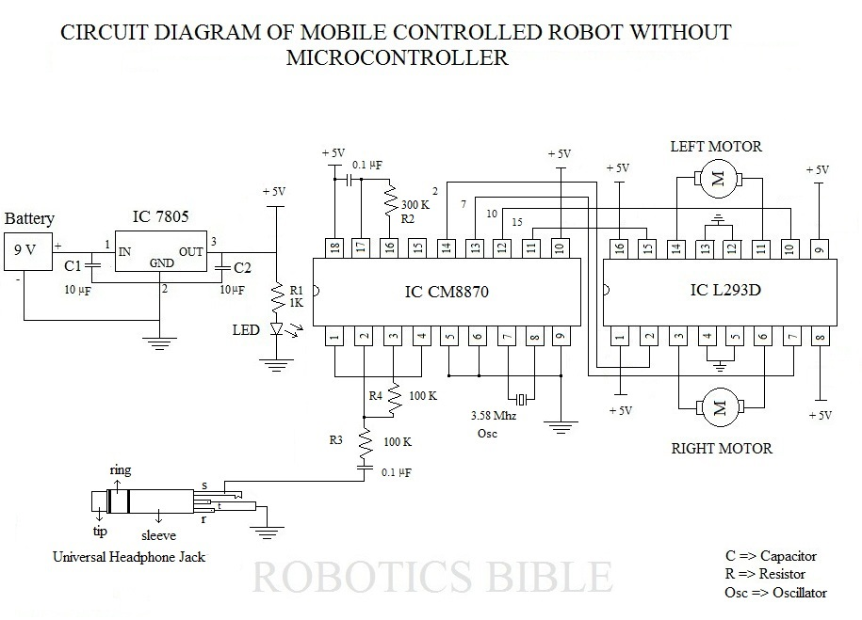](http://www.roboticsbible.com/wp-content/uploads/2012/12/circuit-of-mobile-robot-without-microcontroller.jpg)

**Step by Step Instructions:**

**1)      Power Supply:**

* Take the breadboard and connect the battery holder in horizontal position.
* Insert the positive and negative wire of battery snap in holder.
* Attach IC 7805 (Voltage Regulator), and place one 10 µF capacitor in IN & GND connection of IC 7805 and other in GND & OUT connection.
* Take the positive supply from the battery holder via breadboard wire and place it in IN of IC 7805, and also connect its negative supply in the last row of the breadboard.
* Place the GND of IC 7805 in the last row of the breadboard, and transfer its OUT to the first row of the breadboard.
* As a result of these connections, +5V power is obtained in the first row of the breadboard.
* To check the power flow path, an LED is given a positive supply via 1K Resistor.

**2)      IC CM8870 Connections:**

* Connect 1st & 4th pin of CM8870 (DTMF Receiver) together.
* Pick one 100K resistor and place one side of it in 2nd pin and other side to the 0.1 µf capacitor.
* Pick another 100K resistor and connect 3rd and 2nd pin.
* Provide GND connection to 5th, 6th, and 9th pins.
* Couple 7th and 8th pins with 3.58 MHz Oscillator.
* Provide +5V supply to 10th and 18th pins.
* Take one 300K resistor, and place one side of it to 16th pin and other to 0.1 µf capacitor from 17th pin.
* Connect 0.1 µf capacitor to the 18th pin.

**3)      IC L293D connections:**

* Insert IC L293D (Motor Controller) in the breadboard.
* Supply +5V power to 1st, 8th, 9th, and 16th pins.
* Provide ground connection to 4th, 5th, 12th and 13th pins.
* Attach 2nd, 7th, 10th, and 15th pins of L293D to 14th, 13th, 12th, and 11th pins of IC CM8870 respectively.

**4)      12V DC motor connections:**

* Take the wire of Right Motor and insert it in 3rd and 6th pins of IC L293D.
* Also, place the wire of Left Motor in 11th and 14th pins of IC L293D.

**5)      Universal Headphone Jack Connection:**

* There are three different layers in Universal Headphone Jack such as a Sleeve, Tip, and Ring.
* A closer view of the three layers is shown in the circuit diagram clearly.
* Connect the sleeve to the output of 0.1 µf capacitor (2nd pin) in the IC CM8870.
* Provide GND connection to the tip and ring.

**Working:**

After completing the construction, connect the circuit with 9V battery. Also, connect the universal headphone jack to its respective cell phone with incoming facility. Activate auto-answer mode in the cell phone before connecting it to the circuit, and enable keypad tones in the cell phone that you use to make calls.

Now, your robot is ready to operate wirelessly with GSM facility once you make a call to the cell phone connected to the robot. By pressing the number keypads in the your cell phone, you will be able to move the robot in various directions.

It is made possible with the help of Dual Tone Multi Frequency receiver (IC CM8870), in which the sleeve connection of the robot cell phone is connected to the IC CM8870. The tone received from your cell phone to the robot cell phone will be converted into binary form, and suitable output is provided by the IC CM8870 to IC L293D.

For example, if you press no. 9 in your cell phone, then the robot will move forward (as per this circuit).

**Output:**

|  |  |
| --- | --- |
| **Input given on your cell phone** | **The output obtained from the robot** |
| 1 | Front Right |
| 2 | Reverse Left |
| 3 | Stop |
| 4 | Reverse Right |
| 5 | 360 degree rotation (Right) |
| 6 | Reverse |
| 7 | Reverse Right |
| 8 | Front Left |
| 9 | Forward |
| 0 | 360 degree rotation (Left) |

Catch the action of mobile controlled robot via GSM in the below video:

**Edge Avoider Robot**

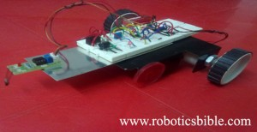

**Introduction:**

*Edge Avoider Robot (EAR)* is a mobile device, which *senses* and *avoids* the absence of surface below it. This simple concept was designed by our *RB researchers* in order to help your robot to protect from *falling*. As like our [previous robotic projects](http://www.roboticsbible.com/category/projects-robotics), this robot is also made without *microcontroller* to make everyone *more comfortable* on developing their own robot.

**Components Required:**

Edge Avoider Robot requires only *simple mechanical* and *electronic* components such as:

* Robot Chassis – 1 no.
* 12V DC motor (60 RPM) – 2 nos.
* Plastic Wheels – 2 or 4 nos. (Based on the chassis)
* Breadboard – 1 no.
* IR Sensor module – 1 no.
* IC 7805 – 1 no.
* IC NE555 – 1 no.
* IC L293D – 1 no.
* 10 µF capacitor – 2 nos.
* 0.1 µF capacitor – 1 no.
* 9V Battery – 1 no. (requires according to the usage)
* Battery Holder – 1 no.
* Battery Snap – 1 no.
* Breadboard Wires – 2 meters
* LED – 1 no.
* 1K & 10K Resistors – Each 1 no.
* 10K Trim Pot – 1 no

*Note: We recommend you to buy spare IC’s for all the IC specified in the component list. This could sometime help you to save your precious time if one IC fails to operate.*

**Circuit Diagram:**

[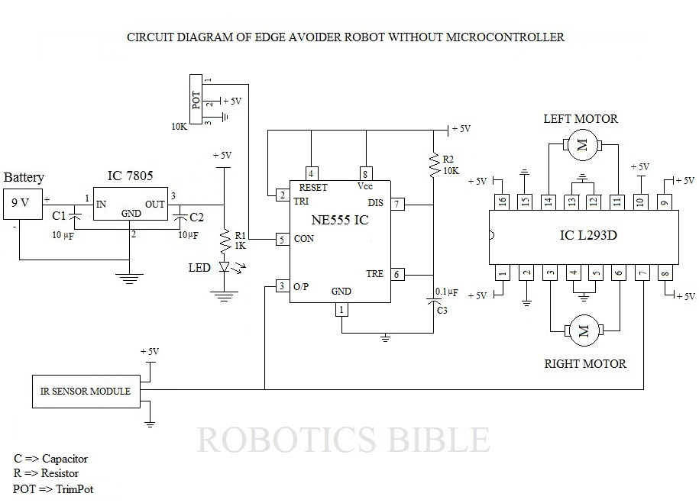](http://www.roboticsbible.com/wp-content/uploads/2012/10/circuit-edge-avoider-robot.jpg)

**Connection Algorithm:**

**1)      Power Supply:**

* Take the breadboard and connect the battery holder in horizontal position.
* Insert the positive and negative wire of battery snap in holder.
* Attach IC 7805 (Voltage Regulator), and place one 10 µF capacitor in IN and GND connection of IC 7805 and other in GND and OUT connection.
* Take the positive supply from the battery holder via breadboard wire and place it in IN of IC 7805, and also connect its negative supply in the last row of the breadboard.
* Place the GND of IC 7805 in the last row of the breadboard, and transfer its OUT to the first row of the breadboard.
* As a result of these connections, +5V power is obtained in the first row of the breadboard.
* To check the power flow path, an LED is placed along with 1K Resistor to the first row of the breadboard.

**2)      IC NE555 and Trim Pot connections:**

* Insert IC NE555 (Timer), and Trim Pot in the breadboard.
* Supply +5V power to Threshold and Discharge connections via 10K Resistor.
* Also, supply +5V power to Vcc, Trigger, and Reset connections.
* Place one connection of GND to ground, and another to +5V via 0.1 µF capacitor and a 10K resistor.
* Couple the 1st connection of Trimpot with Control Voltage of NE555 for generating modulation input.
* Give +5V power and GND for the remaining 2nd and 3rd connection of Trimpot respectively.

**3)      IC L293D connections:**

* Insert IC L293D (Motor Controller) in the breadboard.
* Supply +5V power to 1st, 8th, 9th, 10th, and 16th pins.
* Provide ground connection to 2nd, 4th, 5th, 12th, 13th, and 15th pins.
* Attach 7th pin to Output connection of NE555.

**4)      12V DC motor connections:**

* Take the wire of Right Motor and insert it in 3rd and 6th pins of IC L293D.
* Also, place the wire of Left Motor in 11th and 14th pins of IC L293D.

**5)      IR Sensor Module connections:**

* Give +5V power to IR sensor module’s red-colored wire and ground connection to black-colored wire.
* Place the mid wire of the IR Sensor Module in the 3rd pin of IC NE555.

**Output:**

As soon as finishing the connection works, *make sure* that all the connections are placed in its *relevant* positions. Then, connect a *9V battery* to your robot and make it to move on a *table*. The robot will *move forward* till the IR sensor senses the absence of the *surface underneath*. Once detected, the robot will *turn* to the safest position till the IR sensor *stops* sensing.

If your robot chassis is *more broad*, then fix a *lengthy strip* on the front of the robot and place the IR sensor module on it. This could certainly help your robot to *turn conveniently* without falling sideways.

A *video* of the Edge Avoider Robot without microcontroller is *displayed* below:

Bottom of Form

**Obstacle Avoiding Robot without microcontroller**

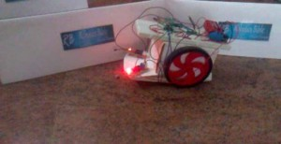

**Introduction:**

An *obstacle avoiding robot* is an intelligent device, which can *automatically* sense and overcome *obstacles* on its path. It is developed without micro-controller in order to *eliminate* critical circuits, difficult programming etc. All you want to do is to just *understand* the circuit diagram and start doing this robot. This simple technique can be incorporated in *wheeled robots* to keep them away from *damages* and *accidents*.

**What’s required?**

This intelligent robot requires *several components* to bring them alive. It doesn’t cost too much, and easily available in all *electronics markets* as well.

* 2 x 12 V DC motor
* 2 x IR Sensor modules
* 1 x IC 7404
* 1 x IC 7805
* 1 x IC L293D
* 1 x Breadboard
* 2 x 10 uf capacitors
* 2 x Plastic wheels
* 1 x Castor wheel
* 1 x Battery (requires according to the usage)
* 1 x Battery holder
* 1 x Battery snap
* 2 meters of Breadboard wires
* 1 meter of Two-core wires
* 2 x 2 feet cardboard (for preparing the body of robot)

**Circuit Diagram:**

**How to assemble them?**

The *circuit diagram* of obstacle avoiding robot is shown in the above picture. It could utmost help you to develop this robot with ease. In case, if you are new to robotics, observe the following *step by step instructions* of all connections given below.

**Preparation of outer part:**

* Cut one square-shaped cardboard and paste one lengthy cardboard below it
* Fix two 12 V DC motors inside the square cardboard in opposite directions
* Connect two plastic wheels on the shaft of the motors
* Fix the castor wheel below the lengthy cardboard
* Place the Right IR Module in top-right of lengthy cardboard, and Left IR Module in top-left of lengthy cardboard.

**Breadboard connections:**

**1)      Power Supply:**

* Take the breadboard and connect the battery holder in horizontal position
* Insert the positive and negative wire of battery snap in holder
* Attach IC 7805 Voltage Regulator, and place one 10 uf capacitor in IN and GND connection of IC 7805 and other in GND and OUT connection.
* Take the positive supply from battery holder via breadboard wire and place it in IN of IC 7805, and also connect its negative supply in last row of breadboard.
* Place the GND of IC 7805 in last row of breadboard, and transfer its OUT to first row of breadboard.
* As a result of these connections, +5 V power is obtained in the first row of breadboard

**2)      Integrated circuit (IC) connections:**

* Insert IC 7404 and IC L293D in the breadboard
* Supply +5 V power to 1st, 8th, 9th, and 16th pins of IC L293D, and 14th pin of IC 7404
* Provide ground connection to 4th, 5th, 12th, and 13th pins of IC L293D, and 7th pin of IC 7404
* Take a breadboard wire and connect the 10th pin of IC 7404 to 7th pin of IC L293D
* Similarly, connect 4th pin of IC 7404 to 10th pin of IC L293D

**3)      12V DC motor connections:**

* Take the wire of Right Motor and insert it in 3rd & 6th pins of IC L293D
* Also, place the wire of Left Motor in 11th and 14th pins of IC L293D

**4)      IR Sensor Module connections:**

* Give +5V power to IR sensor modules via red-colored wire and ground connection via black-colored wire.
* Place the mid wire of Right IR Sensor Module in 11th pin of IC 7404 and 2nd pin of IC L293D
* Connect the mid wire of Left IR Sensor Module in 3rd pin of IC 7404 and 15th pin of IC L293D

**How does it work?**

After finishing the assembling work, connect the *9V battery* via battery snap. Then, see what happens. The robot will *automatically* start traveling on the unstructured path without *hitting* any objects.

When the left IR module senses any obstacles on its way, it will *turn right* till it stops sensing. Similarly, it will *turn left* when the right IR module senses obstacles. If both the sensors sense an obstacle, then the robot will *stop moving*.